**CSCI 1100 – Summer 2015**

**Assignment 3**

**Assignment 3 – Due Wednesday June 3th (11:00pm – night time)**

**Submit on Moodle**

**Name: Liam Gowan**

**Student ID:** B00673126

**Assignments are to be your own work. If you have questions, you can ask your Instructor, course TAs or TAs in the learning centre.**

|  |  |  |
| --- | --- | --- |
| **Declaration: Please complete this declaration** | | |
| 1 | “This document is entirely my own work.” | Yes/no |
| 2 | I obtained help to complete this document. | Yes/no. If Yes, give Details. |
| 3 | This document contains some material copied or cut and pasted from the internet or another document or file or program. | Yes/no. If Yes, give details and provide references. |

**Exercise 1.** Write a program that works as shown in the sample.

The program randomly generates a number between 0 and 100. Then the program asks the user to guess the number. The program tells the user whether random number is higher or lower than the user guess. This continues until the user guesses the correct number. It will then tell the user how many guesses they made. Use a **while loop** for this exercise.

**Printout of Properly Formatted Source Code**

import java.util.Scanner; // imports scanner class  
import java.util.Random; //imports random class  
  
public class RandomGuess{  
 public static void main(String[] args){  
 int numberPicked, numberGuessed, counter;  
 counter = 0;  
 Random randomNumber = new Random();  
 numberPicked = randomNumber.nextInt(101); //makes numberPicked between 0-100  
 Scanner input = new Scanner(System.in);  
   
 System.out.print("Guess a number between 0 and 100." +  
 "\nEnter your guess: ");  
 numberGuessed = input.nextInt();  
   
 /*While the number guessed by user is not equal to the random number,  
 the following block to code will test to see if it's higher or lower,  
 and will then tell the user. It then gets the user to enter another  
 number. Everytime the user makes another guess, the counter goes up by one.  
 */  
   
 while(numberGuessed != numberPicked){  
 if(numberGuessed > numberPicked){  
 System.out.print("Your guess is too high." +  
 "\nEnter your guess: ");  
 numberGuessed = input.nextInt();  
 }  
 else{  
 System.out.print("Your guess is too low." +  
 "\nEnter your guess: ");  
 numberGuessed = input.nextInt();  
 }  
 counter++;  
 }  
   
 //Congratulations user and tells them # of guesses.  
 System.out.print("Great job. You guessed the correct number in "  
 + (counter + 1) + " guesses!");  
 }  
}

**Example output/test cases (3 tests – different than above).**

**Test 1.**

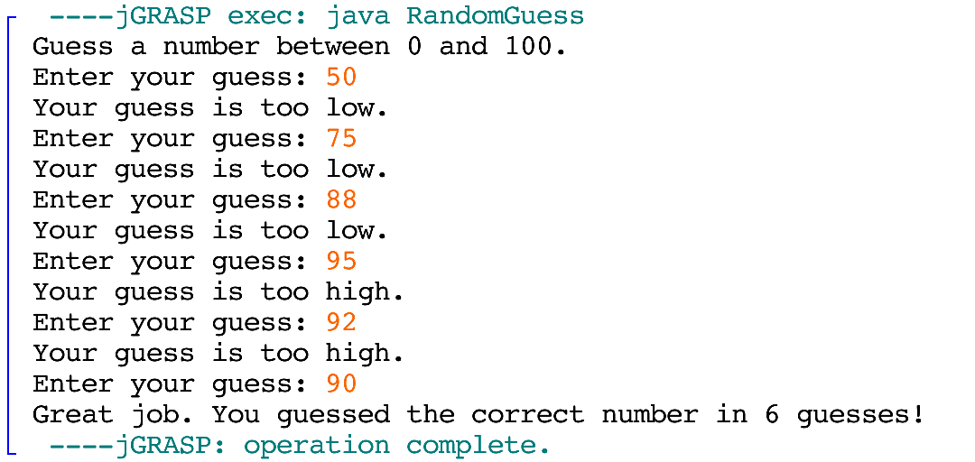

**Test 2.**

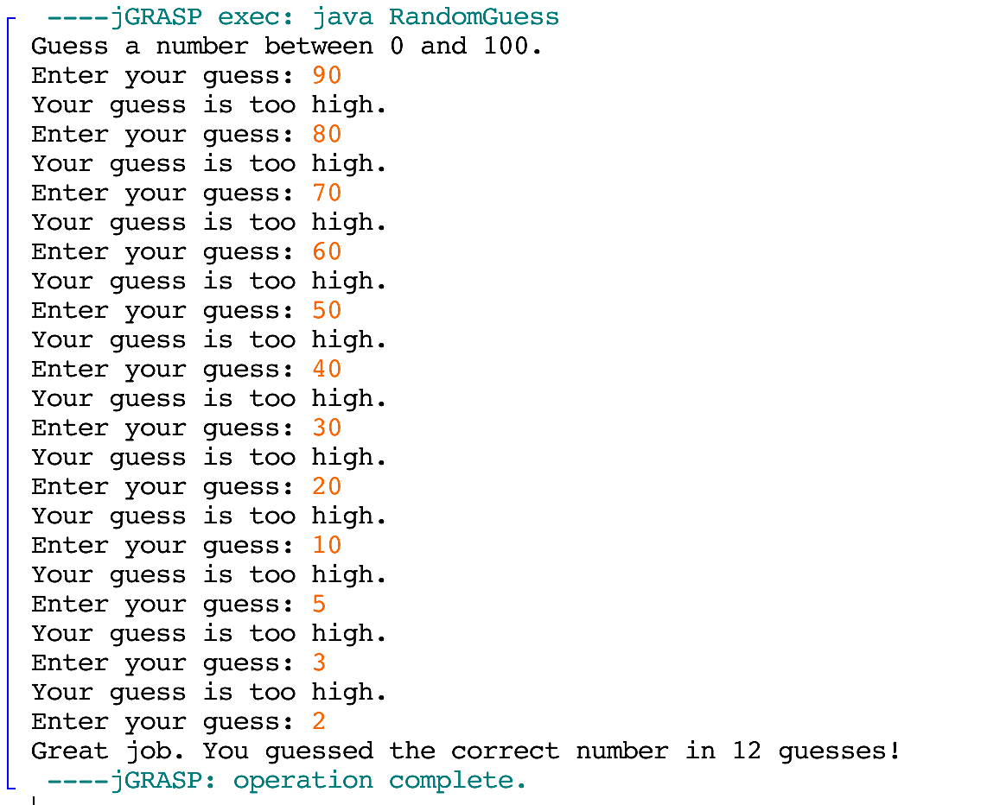

**Test 3.**

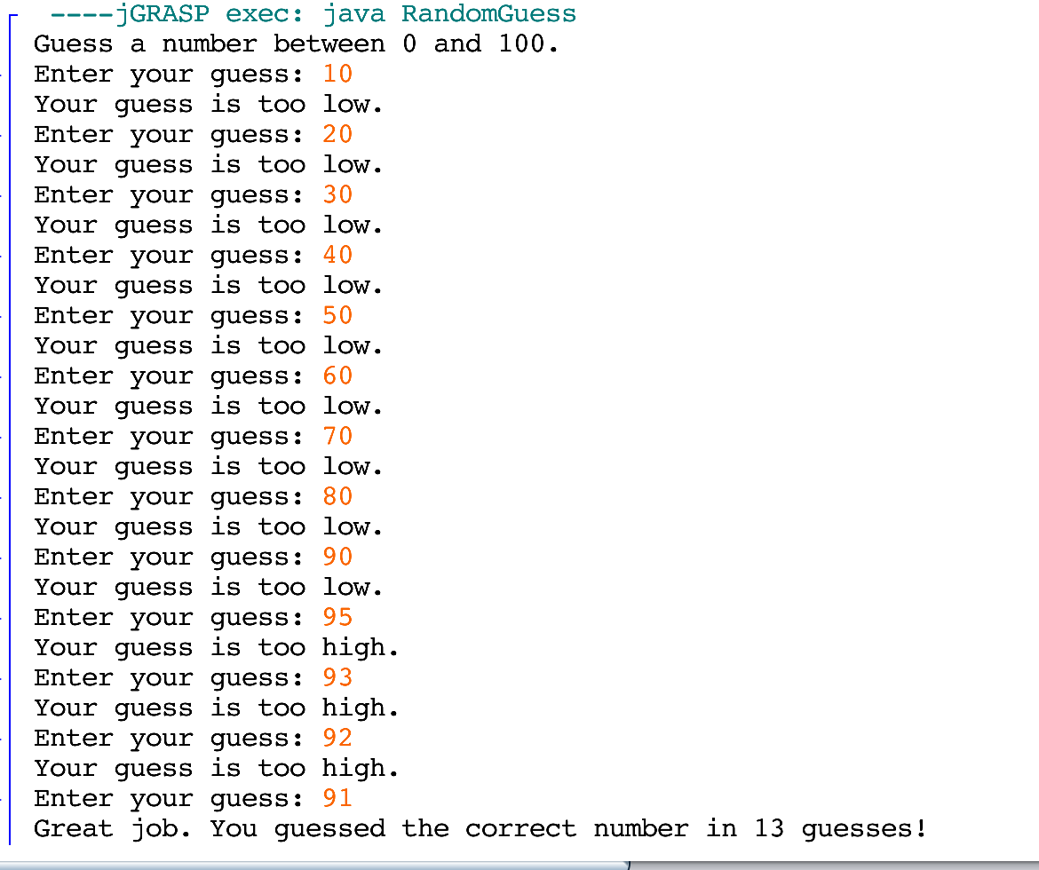

**Exercise 2.** Write a program that asks a user to enter a word and a letter. Then print the word in capital letters, the number of letters in the word, and how many times the letter occurs in the word. Finally print out the word (in capitals) backwards. You can **use either a while loop or for loop** if needed for this exercise.

**Printout of Properly Formatted Source Code**

import java.util.Scanner; //import scanner class  
  
public class EnterWordString{  
 public static void main(String[] args){  
 String word, wordCAP, letterPicked;   
 char letter;  
 Scanner input = new Scanner(System.in);  
 int letterCounter = 0; //initializes letterCounter to 0  
   
 /*Prompts user for word, saves it to 'word' string variable.  
 Program then prompts user for letter, which is saved to the  
 string variable 'letterPicked', and char variable 'letter'  
 is the first character of letterPicked. */  
 System.out.print("Enter a word: ");   
 word = input.nextLine();  
 System.out.print("Enter a letter: ");  
 letterPicked = input.nextLine();  
 letter = letterPicked.charAt(0);  
   
 wordCAP = word.toUpperCase(); //converts word to capitals, saves to 'wordCAP'  
   
 //Tells user word in caps, and then the length.  
 System.out.println("\nThe word is " + wordCAP + ".");  
 System.out.println("There are " + word.length() + " letters in the word.");  
   
 //For loop determines how many of selected letter are present  
 for(int i = 0; i < word.length(); i++){  
 if(letter == word.charAt(i))  
 letterCounter++;  
 }  
 //Displays how many of the selected letter are in 'word'.  
 System.out.println("Number of " + letter + "'s in the word: " +   
 letterCounter + ".");  
 System.out.print("The word backwards is ");  
   
 int numberOfLetters = wordCAP.length();  
   
 //Prints word in reverse  
 for(int j = 1; j <= numberOfLetters; j++){  
 System.out.print(wordCAP.charAt(numberOfLetters - j));  
 }   
 }  
}

**Example output/test cases (2 tests – different than above).**

**Test 1.**

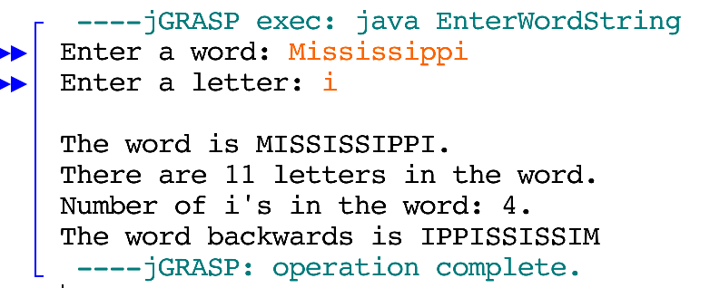

**Test 2.**

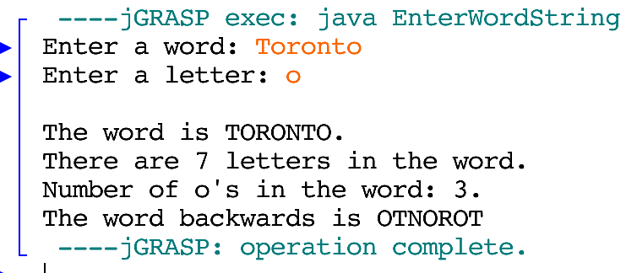

**Exercise 3.** Write a program that calculates the shipping fee for an online bookstore. The program will prompt the user to enter the number of books they wish to order. Then the program will ask the user to enter the cost of each book. The program will total up the amount of all the books and apply the shipping fee based on the total amount of the books. The program will ask the customer to enter where they want to ship the order: Within Canada, to the USA, or other (International). Then the program may add an additional fee based on where the customer wants to ship the order. For example, if the books are to be shipped within Canada there is no additional fee, but to send the order to the US would cost an additional $25 dollars. Use a **for loop** for this exercise. See below for shipping costs:

Shipping fee based on cost:

An order that costs less than $50: 5% of the total

An order that costs between $50 dollars and $100: 15% of the total

Orders that cost more than $100: 25% of the total

In addition to shipping based on the total cost of the order, location fee chart:

Shipping within Canada: free

Shipping to the US: $25 dollars

Shipping to other: $50 dollars

**Printout of Properly Formatted Source Code**

import java.util.Scanner; // import scanner class  
  
public class BookOrder{  
 public static void main(String[] args){  
 int numBooks, location;  
 double sum = 0;  
 double cost, orderFee, total, locationFee;  
 Scanner input = new Scanner(System.in); //declare scanner variable  
   
 //prompt user for # of books, assign to 'numBooks'  
 System.out.print("Enter the number of books you are buying: ");  
 numBooks = input.nextInt();  
   
 /*For when i is less than or equal to the number of books, program  
 will ask for the price of each book and calculate a sum*/  
 for(int i = 1; i <= numBooks; i++){  
 System.out.print("Enter the cost for book " + i + ": $");  
 cost = input.nextDouble();  
 sum = sum + cost;  
 }  
   
 System.out.print("Where do you want to ship the order?" +  
 "\nEnter 1 to ship within Canada," +  
 "\nEnter 2 to ship to the US," +  
 "\nEnter any other number to ship to an " +  
 "International location: ");  
 location = input.nextInt();  
   
 //Calculates cost of shipping  
 if(location == 1)  
 locationFee = 0;  
 else if(location == 2)  
 locationFee = 25;  
 else  
 locationFee = 50;  
   
 //calculates the order fee depending on price of product  
 if(sum < 50)  
 orderFee = sum * 0.05;  
 else if(sum >= 50 && sum <= 100)  
 orderFee = sum * 0.15;  
 else  
 orderFee = sum * 0.25;  
   
 //displays total cost of books (sum), orderFee and locationFee  
 System.out.println("\nTotal cost for the books: $" + sum +  
 "\nShipping Fee based on order amount: $" + orderFee +  
 "\nShipping Fee based on location: $" + locationFee);  
   
 total = sum + orderFee + locationFee; //calculates total  
   
 //displays total cost of books with shipping  
 System.out.print("\nTotal cost with shipping: $" + total);  
 }  
}

**Example output/test cases (4 test cases – show a good representation of the potential options).**

**Test 1.**

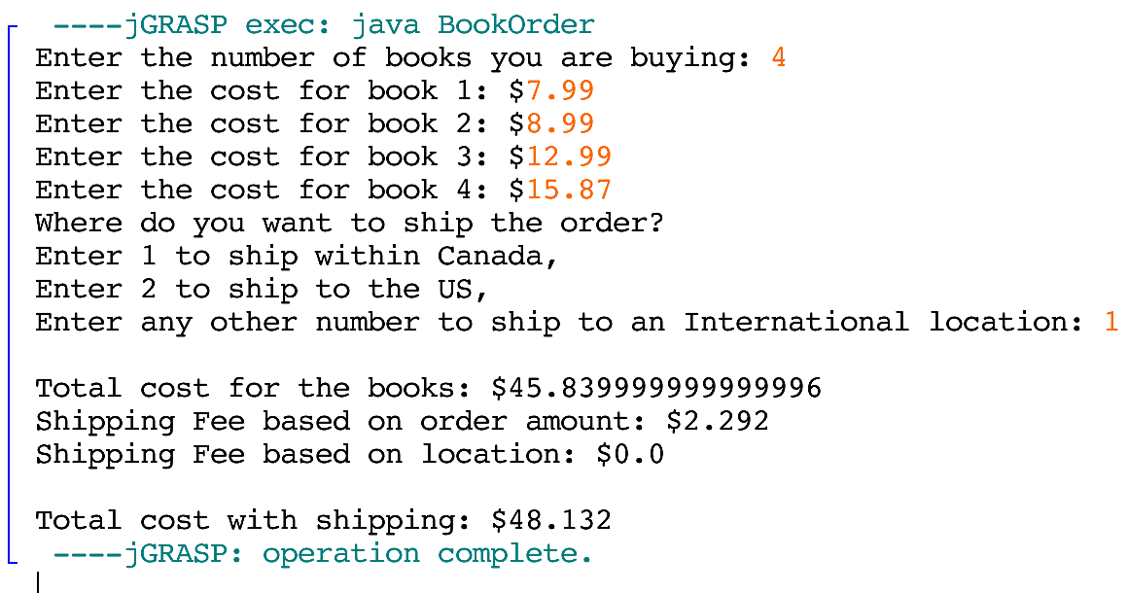

**Test 2.**

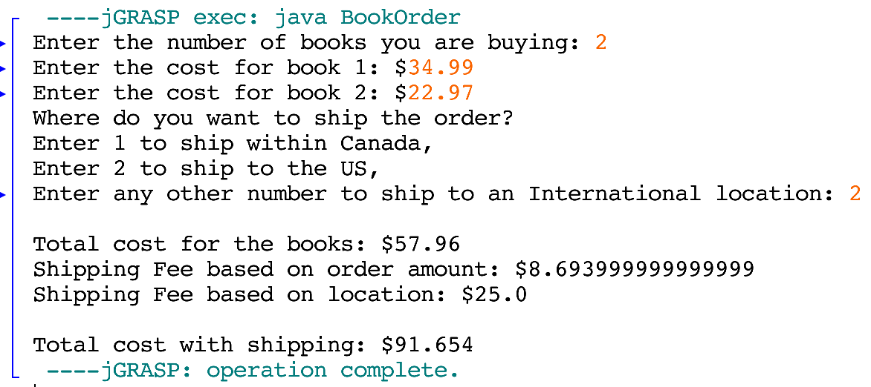

**Test 3.**

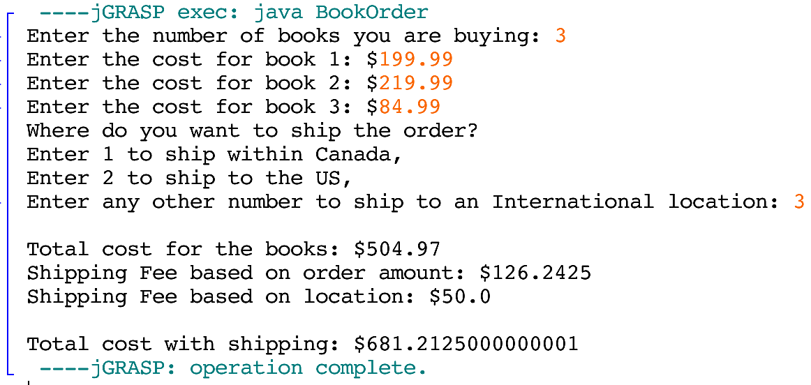

**Test 4.**

